**EXP NO: 08 DATE: 14-03-24**

**Aim:** To Create a simple cloud web application for student counselling system using any Cloud Service Provider to demonstrate SaaS with the fields of student name, age, address, phone, subjects studied, Year of passing, percentage of marks, domain interest, etc.

**Implementation:**

1.Go to Zoho.com and login/signup

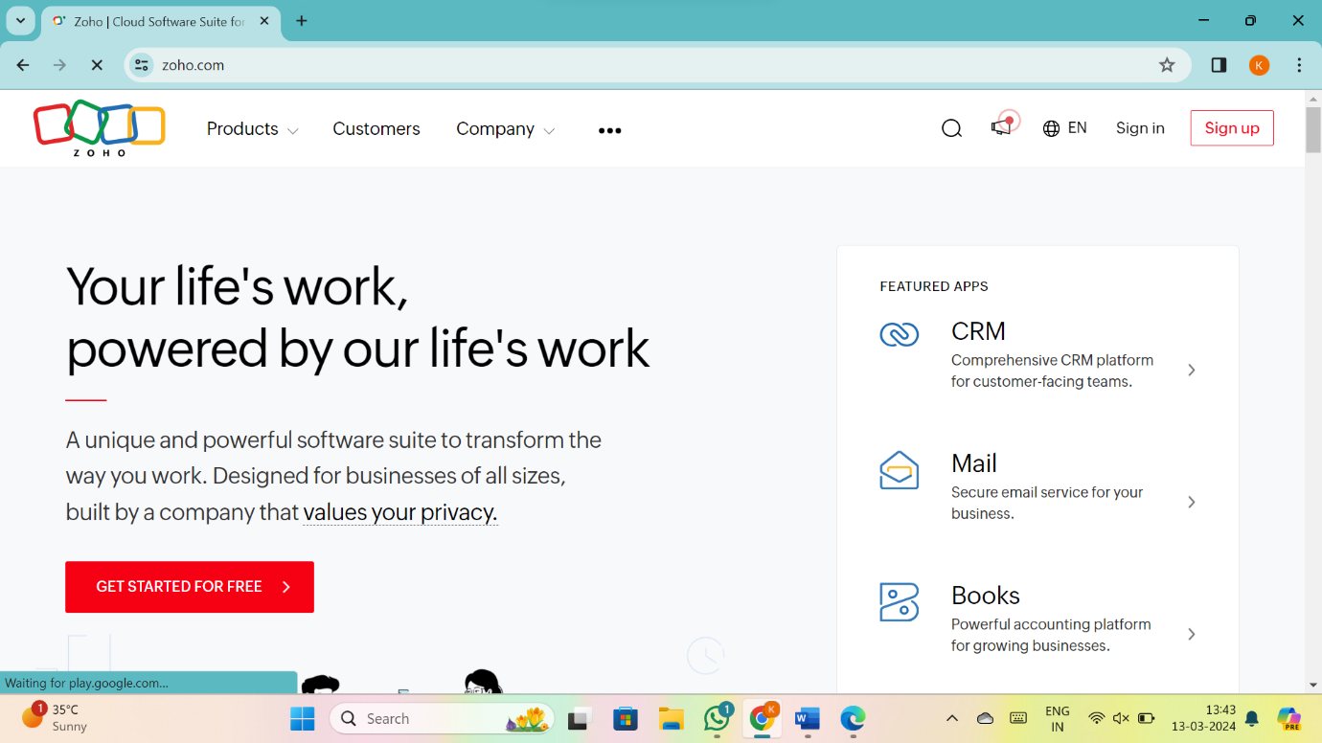

2.Go to Creator

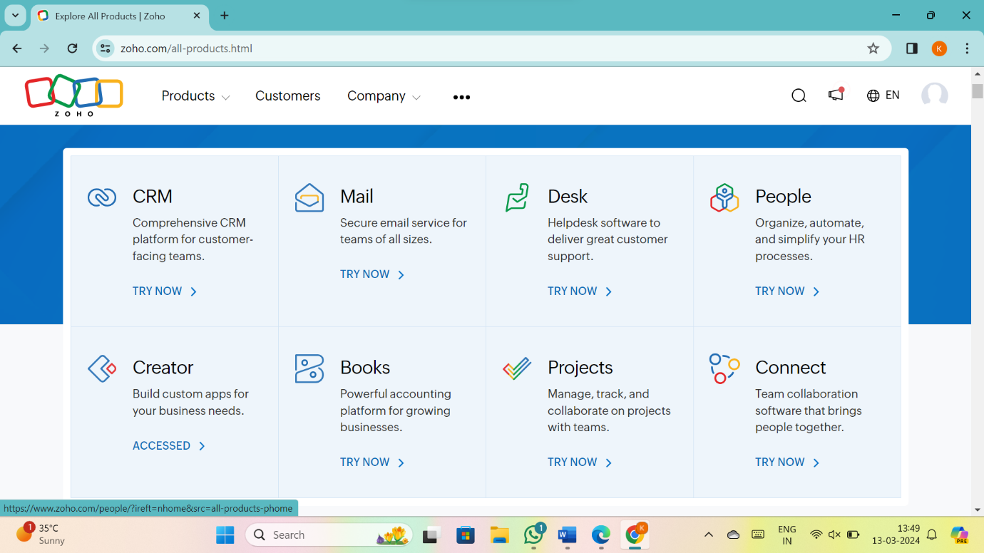

3. CREATE NEW APPLICATION

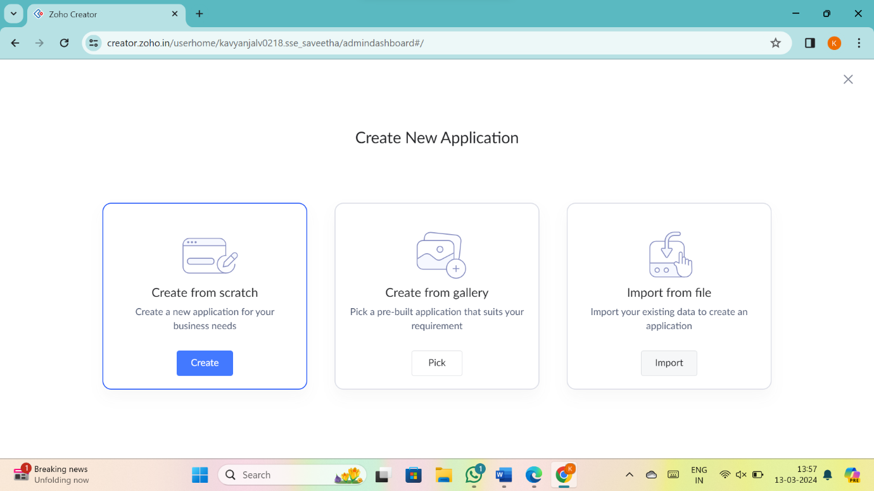

4.Give Application Name

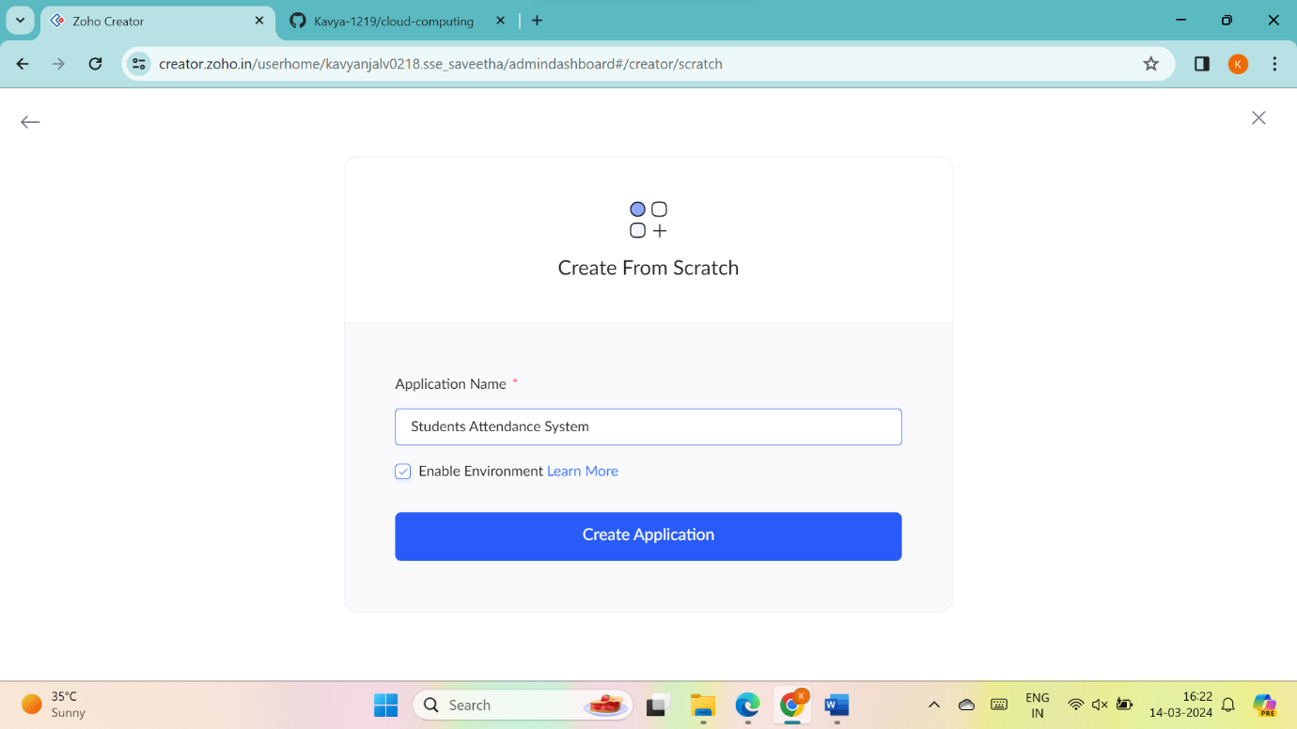

5.Create New Form

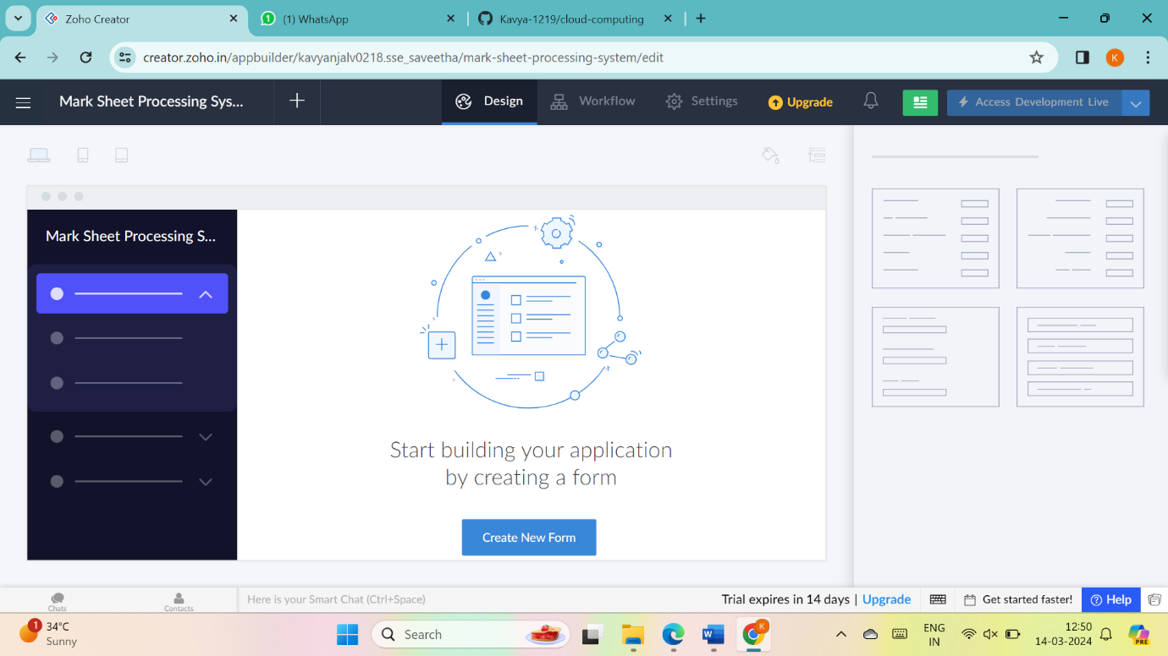

6.Select Form and give name

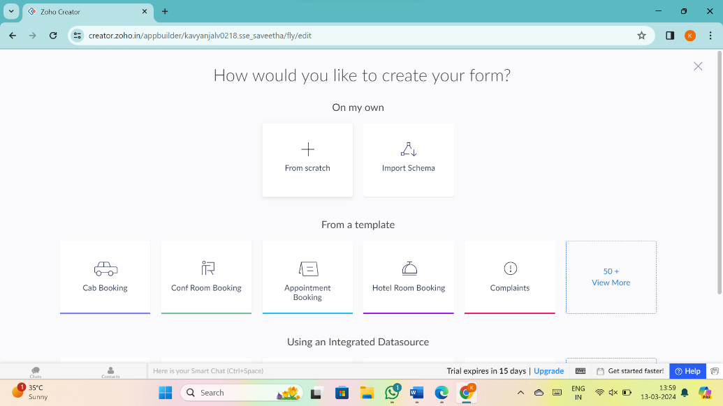

7.Drag necessary fields

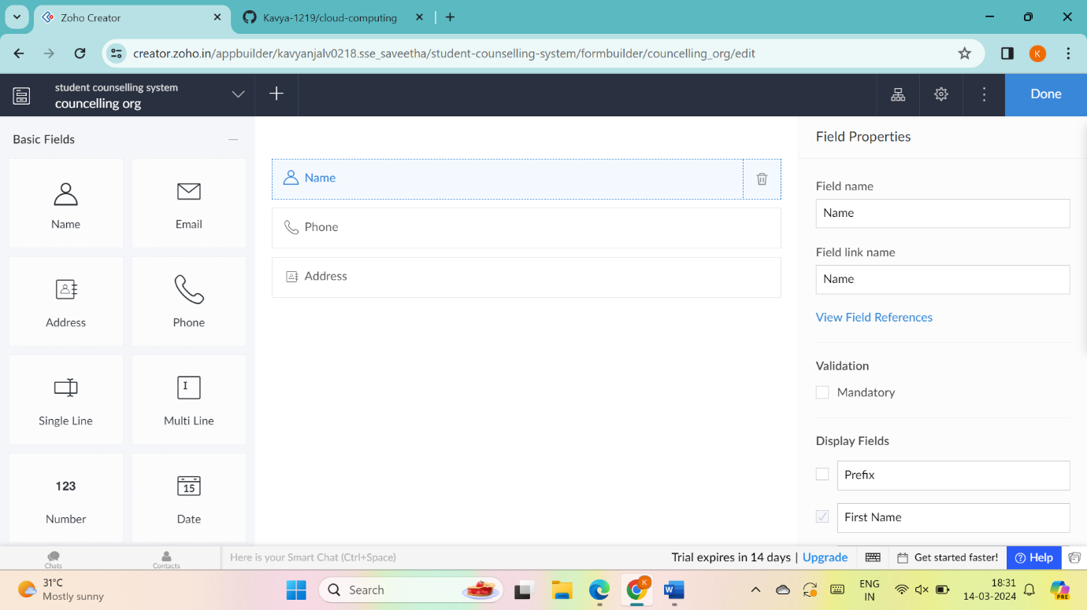

8.create new forms if necessary

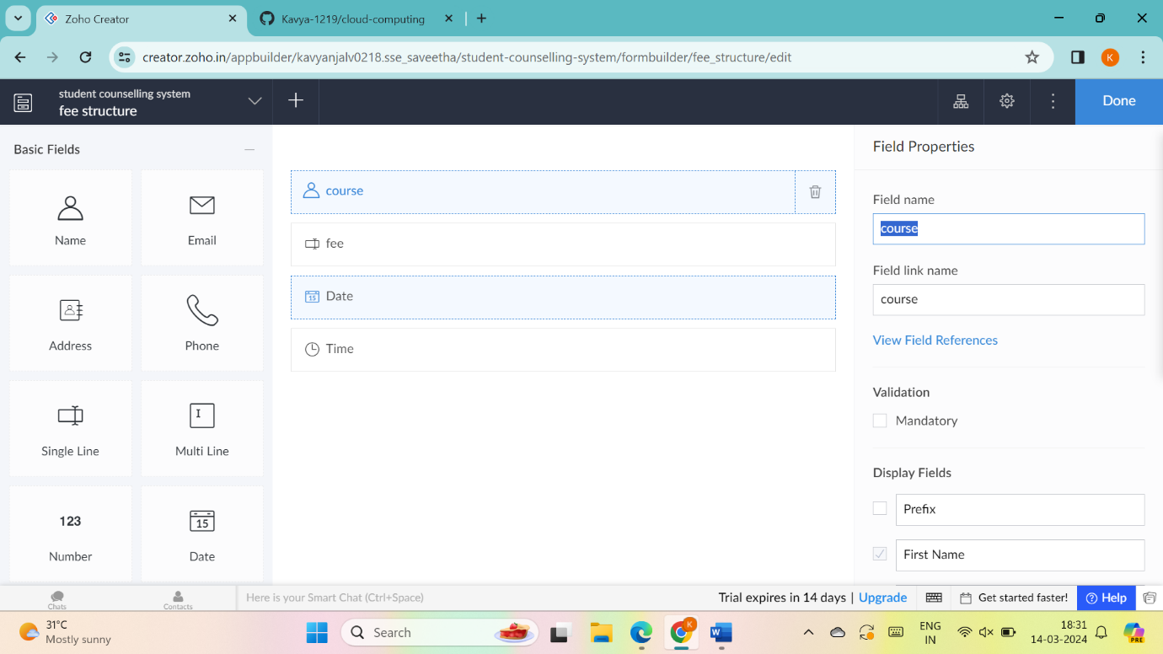

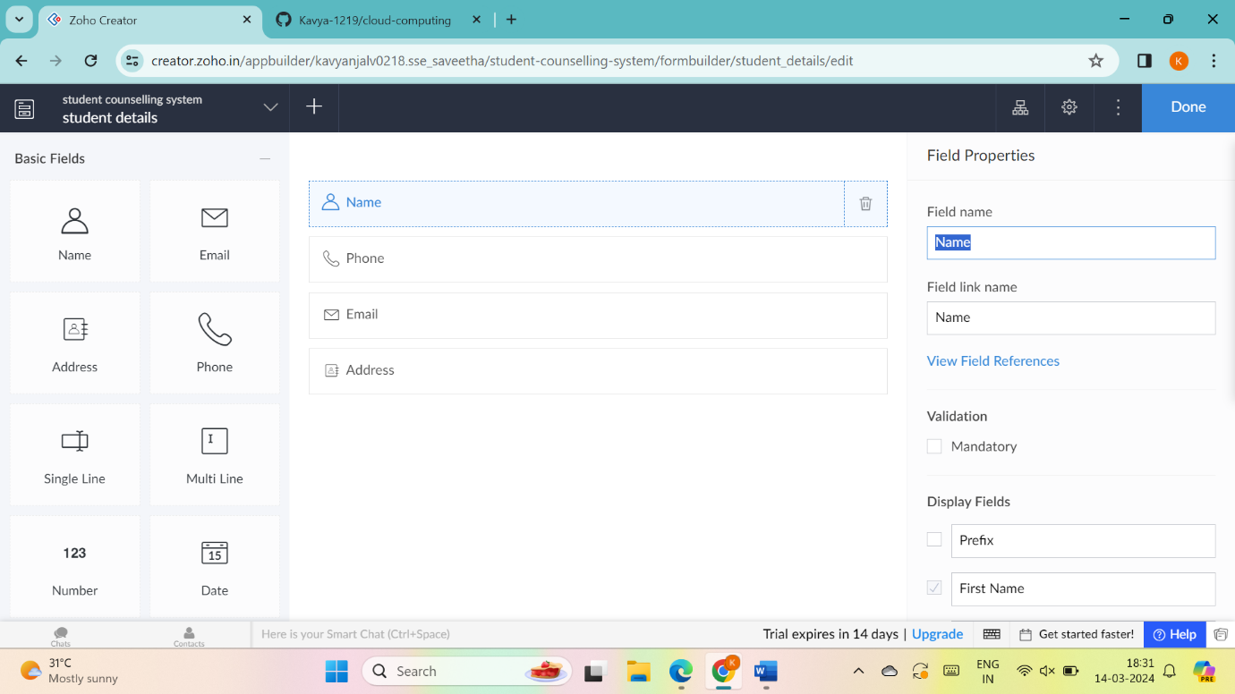

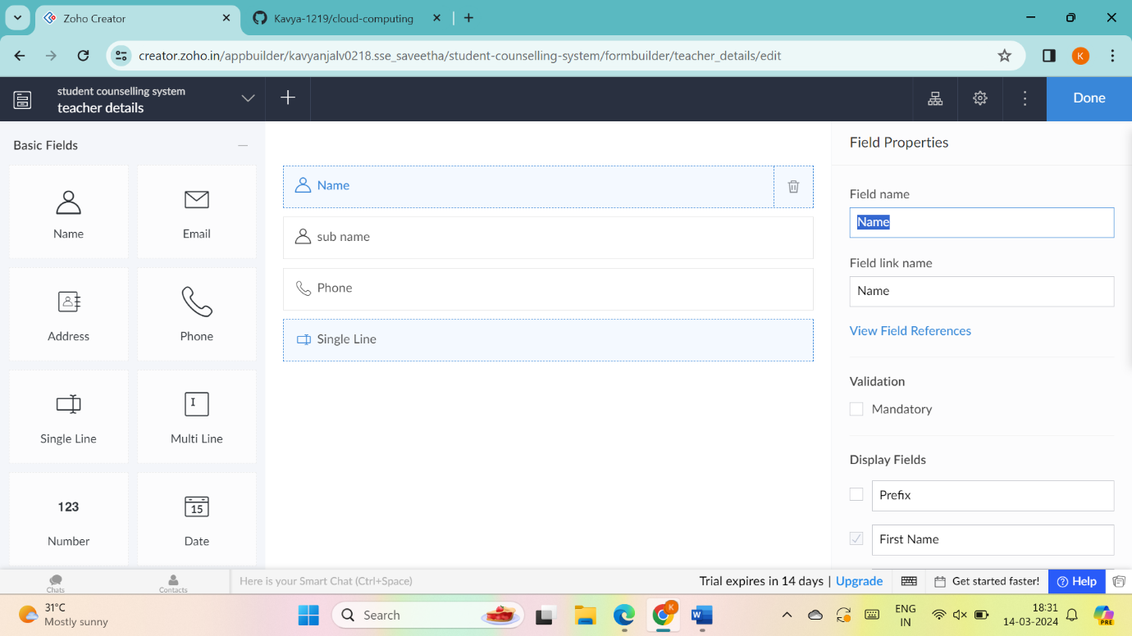

9.the software has been created

